library(psych)  
library(GPArotation)  
library(paran)

## Loading required package: MASS

library(GGally)  
library(plyr)  
HCP.Data<-read.csv("unrestricted_sigmundson_12_5_2017_15_25_44.csv",header=TRUE)  
flanker<-HCP.Data[,"Flanker_Unadj"]  
sequence<-HCP.Data[,"PicSeq_Unadj"]  
wmTask<-HCP.Data[,"WM_Task_Acc"]  
cardSort<-HCP.Data[,"CardSort_Unadj"]  
listSort<-HCP.Data[,"ListSort_Unadj"]  
wordMem<-HCP.Data[,"IWRD_TOT"]  
wordMemReac<-HCP.Data[,"IWRD_RTC"]  
orientation<-HCP.Data[,"VSPLOT_TC"]  
HCP<-data.frame(Flanker=flanker,PictureSequence=sequence,WorkingMem=wmTask,CardSorting=cardSort,ListSorting=listSort,WordMemory=wordMem,SpatialOrient=orientation,WordMemoryReact=wordMemReac)  
#removing missing data  
OmitHCP<-na.omit(HCP)  
#examining correlations  
CorHCP<-cor(OmitHCP)  
CorHCP

## Flanker PictureSequence WorkingMem CardSorting  
## Flanker 1.00000000 0.1237895 0.2150420 0.5142051  
## PictureSequence 0.12378952 1.0000000 0.2977920 0.1835754  
## WorkingMem 0.21504203 0.2977920 1.0000000 0.3305329  
## CardSorting 0.51420505 0.1835754 0.3305329 1.0000000  
## ListSorting 0.12564338 0.3155067 0.3607569 0.1787235  
## WordMemory 0.06053937 0.2053973 0.2266847 0.1368996  
## SpatialOrient 0.18958976 0.2000888 0.3312082 0.2407748  
## WordMemoryReact -0.15956806 -0.1309848 -0.2115624 -0.1690018  
## ListSorting WordMemory SpatialOrient WordMemoryReact  
## Flanker 0.1256434 0.06053937 0.18958976 -0.15956806  
## PictureSequence 0.3155067 0.20539734 0.20008881 -0.13098478  
## WorkingMem 0.3607569 0.22668470 0.33120820 -0.21156235  
## CardSorting 0.1787235 0.13689964 0.24077478 -0.16900184  
## ListSorting 1.0000000 0.13850951 0.26726782 -0.12347499  
## WordMemory 0.1385095 1.00000000 0.13041960 -0.29211509  
## SpatialOrient 0.2672678 0.13041960 1.00000000 -0.03665983  
## WordMemoryReact -0.1234750 -0.29211509 -0.03665983 1.00000000

ggcorr(OmitHCP)

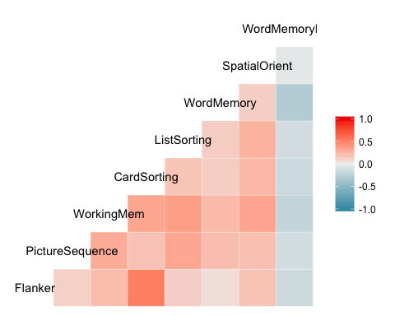

#examining factorability  
cortest.bartlett(OmitHCP)

## R was not square, finding R from data

## $chisq  
## [1] 1204.008  
##   
## $p.value  
## [1] 7.999126e-236  
##   
## $df  
## [1] 28

KMO(OmitHCP)

## Kaiser-Meyer-Olkin factor adequacy  
## Call: KMO(r = OmitHCP)  
## Overall MSA = 0.73  
## MSA for each item =   
## Flanker PictureSequence WorkingMem CardSorting   
## 0.64 0.80 0.78 0.68   
## ListSorting WordMemory SpatialOrient WordMemoryReact   
## 0.77 0.71 0.79 0.70

#checking factors to retain  
pc<-principal(OmitHCP,nfactors=8,rotate="none")  
plot(pc$values,type="b")

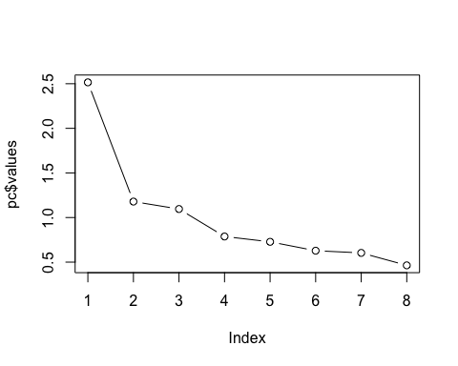

paran(OmitHCP, iterations = 240, centile = 0, quietly = FALSE, status = TRUE, all = TRUE, cfa = TRUE, graph = TRUE, color = TRUE, col = c("black", "red", "blue"), lty = c(1, 2, 3), lwd = 1, legend = TRUE, file = "", width = 640, height = 640, grdevice = "png", seed = 0)

##   
## Using eigendecomposition of correlation matrix.  
## Computing: 10% 20% 30% 40% 50% 60% 70% 80% 90% 100%  
##   
##   
## Results of Horn's Parallel Analysis for factor retention  
## 240 iterations, using the mean estimate  
##   
## --------------------------------------------------   
## Factor Adjusted Unadjusted Estimated   
## Eigenvalue Eigenvalue Bias   
## --------------------------------------------------   
## No components passed.   
## --------------------------------------------------   
## 1 1.612891 1.746538 0.133647  
## 2 0.342098 0.429668 0.087569  
## 3 0.192859 0.244501 0.051641  
## 4 -0.061031 -0.04131 0.019718  
## 5 -0.087134 -0.09850 -0.01137  
## 6 -0.110253 -0.15109 -0.04084  
## 7 -0.129467 -0.20412 -0.07465  
## 8 -0.133604 -0.24811 -0.11451  
## --------------------------------------------------   
##   
## Adjusted eigenvalues > 0 indicate dimensions to retain.  
## (3 factors retained)

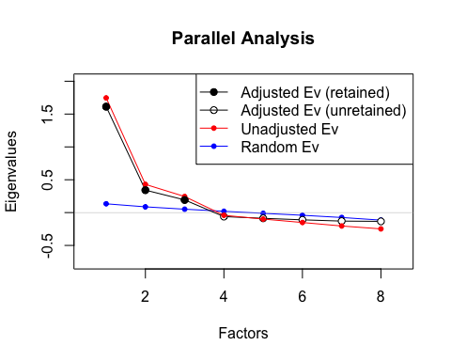

#examining residuals with 3 factors  
pcunrot<-principal(OmitHCP,nfactors=3,rotate="none")  
residuals<-factor.residuals(CorHCP,pcunrot$loadings)  
residuals<-as.matrix(residuals[upper.tri(residuals)])  
count(abs(residuals)>.05)

## x freq  
## 1 FALSE 8  
## 2 TRUE 20

sqrt(mean(residuals^2))

## [1] 0.1155274

hist(residuals)

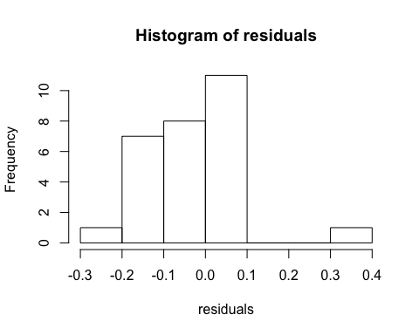

#running the analysis with 2 factors  
principal(OmitHCP,nfactors=2,rotate="oblimin",scores=TRUE)

## Principal Components Analysis  
## Call: principal(r = OmitHCP, nfactors = 2, rotate = "oblimin", scores = TRUE)  
## Standardized loadings (pattern matrix) based upon correlation matrix  
## TC1 TC2 h2 u2 com  
## Flanker -0.07 0.87 0.73 0.27 1.0  
## PictureSequence 0.65 -0.03 0.41 0.59 1.0  
## WorkingMem 0.61 0.24 0.51 0.49 1.3  
## CardSorting 0.09 0.81 0.71 0.29 1.0  
## ListSorting 0.63 0.03 0.41 0.59 1.0  
## WordMemory 0.66 -0.19 0.40 0.60 1.2  
## SpatialOrient 0.39 0.30 0.30 0.70 1.9  
## WordMemoryReact -0.47 -0.01 0.22 0.78 1.0  
##   
## TC1 TC2  
## SS loadings 2.05 1.64  
## Proportion Var 0.26 0.20  
## Cumulative Var 0.26 0.46  
## Proportion Explained 0.56 0.44  
## Cumulative Proportion 0.56 1.00  
##   
## With component correlations of   
## TC1 TC2  
## TC1 1.00 0.27  
## TC2 0.27 1.00  
##   
## Mean item complexity = 1.2  
## Test of the hypothesis that 2 components are sufficient.  
##   
## The root mean square of the residuals (RMSR) is 0.12   
## with the empirical chi square 845.79 with prob < 2.1e-172   
##   
## Fit based upon off diagonal values = 0.74

principal(OmitHCP,nfactors=2,rotate="varimax",scores=TRUE)

## Principal Components Analysis  
## Call: principal(r = OmitHCP, nfactors = 2, rotate = "varimax", scores = TRUE)  
## Standardized loadings (pattern matrix) based upon correlation matrix  
## RC1 RC2 h2 u2 com  
## Flanker 0.01 0.85 0.73 0.27 1.0  
## PictureSequence 0.64 0.09 0.41 0.59 1.0  
## WorkingMem 0.62 0.35 0.51 0.49 1.6  
## CardSorting 0.16 0.82 0.71 0.29 1.1  
## ListSorting 0.62 0.14 0.41 0.59 1.1  
## WordMemory 0.63 -0.07 0.40 0.60 1.0  
## SpatialOrient 0.41 0.37 0.30 0.70 2.0  
## WordMemoryReact -0.46 -0.10 0.22 0.78 1.1  
##   
## RC1 RC2  
## SS loadings 1.98 1.71  
## Proportion Var 0.25 0.21  
## Cumulative Var 0.25 0.46  
## Proportion Explained 0.54 0.46  
## Cumulative Proportion 0.54 1.00  
##   
## Mean item complexity = 1.2  
## Test of the hypothesis that 2 components are sufficient.  
##   
## The root mean square of the residuals (RMSR) is 0.12   
## with the empirical chi square 845.79 with prob < 2.1e-172   
##   
## Fit based upon off diagonal values = 0.74

#running the analysis with 3 factors  
pc1<-principal(OmitHCP,nfactors=3,rotate="oblimin",scores=TRUE)  
pc1

## Principal Components Analysis  
## Call: principal(r = OmitHCP, nfactors = 3, rotate = "oblimin", scores = TRUE)  
## Standardized loadings (pattern matrix) based upon correlation matrix  
## TC1 TC2 TC3 h2 u2 com  
## Flanker -0.05 0.88 0.00 0.76 0.24 1.0  
## PictureSequence 0.64 -0.09 0.16 0.45 0.55 1.2  
## WorkingMem 0.61 0.19 0.16 0.53 0.47 1.3  
## CardSorting 0.10 0.81 0.05 0.72 0.28 1.0  
## ListSorting 0.76 -0.07 -0.01 0.55 0.45 1.0  
## WordMemory 0.16 -0.11 0.75 0.61 0.39 1.1  
## SpatialOrient 0.64 0.19 -0.21 0.48 0.52 1.4  
## WordMemoryReact 0.10 -0.14 -0.81 0.68 0.32 1.1  
##   
## TC1 TC2 TC3  
## SS loadings 1.87 1.58 1.33  
## Proportion Var 0.23 0.20 0.17  
## Cumulative Var 0.23 0.43 0.60  
## Proportion Explained 0.39 0.33 0.28  
## Cumulative Proportion 0.39 0.72 1.00  
##   
## With component correlations of   
## TC1 TC2 TC3  
## TC1 1.00 0.24 0.20  
## TC2 0.24 1.00 0.15  
## TC3 0.20 0.15 1.00  
##   
## Mean item complexity = 1.1  
## Test of the hypothesis that 3 components are sufficient.  
##   
## The root mean square of the residuals (RMSR) is 0.12   
## with the empirical chi square 808.7 with prob < 2.5e-170   
##   
## Fit based upon off diagonal values = 0.75

principal(OmitHCP,nfactors=3,rotate="varimax",scores=TRUE)

## Principal Components Analysis  
## Call: principal(r = OmitHCP, nfactors = 3, rotate = "varimax", scores = TRUE)  
## Standardized loadings (pattern matrix) based upon correlation matrix  
## RC1 RC2 RC3 h2 u2 com  
## Flanker 0.06 0.87 0.05 0.76 0.24 1.0  
## PictureSequence 0.64 -0.01 0.22 0.45 0.55 1.2  
## WorkingMem 0.64 0.27 0.23 0.53 0.47 1.6  
## CardSorting 0.21 0.82 0.11 0.72 0.28 1.2  
## ListSorting 0.74 0.01 0.06 0.55 0.45 1.0  
## WordMemory 0.22 -0.03 0.75 0.61 0.39 1.2  
## SpatialOrient 0.64 0.24 -0.13 0.48 0.52 1.4  
## WordMemoryReact 0.01 -0.19 -0.80 0.68 0.32 1.1  
##   
## RC1 RC2 RC3  
## SS loadings 1.87 1.58 1.34  
## Proportion Var 0.23 0.20 0.17  
## Cumulative Var 0.23 0.43 0.60  
## Proportion Explained 0.39 0.33 0.28  
## Cumulative Proportion 0.39 0.72 1.00  
##   
## Mean item complexity = 1.2  
## Test of the hypothesis that 3 components are sufficient.  
##   
## The root mean square of the residuals (RMSR) is 0.12   
## with the empirical chi square 808.7 with prob < 2.5e-170   
##   
## Fit based upon off diagonal values = 0.75

#examining factor loadings  
scores<-pc1$scores  
plot(scores)

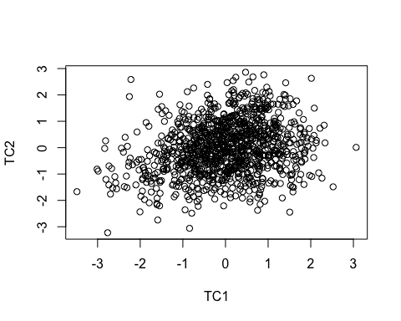

boxplot(scores)

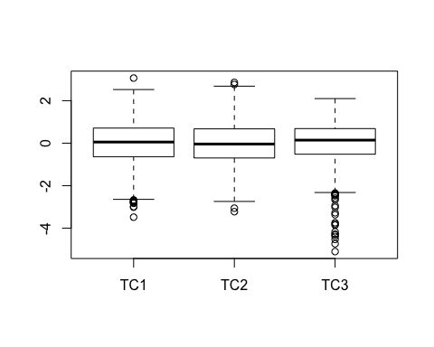

#running factor analyses for comparison  
factanal(OmitHCP,3,"oblimin")

##   
## Call:  
## factanal(x = OmitHCP, factors = 3, data = "oblimin")  
##   
## Uniquenesses:  
## Flanker PictureSequence WorkingMem CardSorting   
## 0.580 0.752 0.571 0.363   
## ListSorting WordMemory SpatialOrient WordMemoryReact   
## 0.666 0.846 0.761 0.005   
##   
## Loadings:  
## Factor1 Factor2 Factor3  
## Flanker 0.119 0.632   
## PictureSequence 0.483   
## WorkingMem 0.595 0.233 -0.143   
## CardSorting 0.232 0.761   
## ListSorting 0.569   
## WordMemory 0.280 -0.269   
## SpatialOrient 0.448 0.195   
## WordMemoryReact -0.112 0.988   
##   
## Factor1 Factor2 Factor3  
## SS loadings 1.264 1.097 1.094  
## Proportion Var 0.158 0.137 0.137  
## Cumulative Var 0.158 0.295 0.432  
##   
## Test of the hypothesis that 3 factors are sufficient.  
## The chi square statistic is 17.96 on 7 degrees of freedom.  
## The p-value is 0.0121

factanal(OmitHCP,3,"varimax")

##   
## Call:  
## factanal(x = OmitHCP, factors = 3, data = "varimax")  
##   
## Uniquenesses:  
## Flanker PictureSequence WorkingMem CardSorting   
## 0.580 0.752 0.571 0.363   
## ListSorting WordMemory SpatialOrient WordMemoryReact   
## 0.666 0.846 0.761 0.005   
##   
## Loadings:  
## Factor1 Factor2 Factor3  
## Flanker 0.119 0.632   
## PictureSequence 0.483   
## WorkingMem 0.595 0.233 -0.143   
## CardSorting 0.232 0.761   
## ListSorting 0.569   
## WordMemory 0.280 -0.269   
## SpatialOrient 0.448 0.195   
## WordMemoryReact -0.112 0.988   
##   
## Factor1 Factor2 Factor3  
## SS loadings 1.264 1.097 1.094  
## Proportion Var 0.158 0.137 0.137  
## Cumulative Var 0.158 0.295 0.432  
##   
## Test of the hypothesis that 3 factors are sufficient.  
## The chi square statistic is 17.96 on 7 degrees of freedom.  
## The p-value is 0.0121